**Different ways to create a database**

1)Right click on Database and select new database and enter the name.

2)we can create the database by using the below query

create database Sample2

whenever we create database either it is system defined DB or user defined DB there are two files generated automatically.

Right click on DB🡪Properties🡪Files🡪on the right hand sides there are two DB files

.MDF file-Data file contains actual data

.LDF file – Transaction log file. We use this log file to recover DB incase if we have any problems.

**Rename the DB:**

1)Right click on DB🡪Rename

2)By using alter Command

Alter database Sample2 Modify Name = Sample 3

3)Alternatively, you can also use system stored procedure.

sp_renameDB ‘OldDBName’ , ‘NewDBName’

**Drop or Deleting a Database:**

1)Right click on the DB and select delete. When you do this it will also delete the two mdf files

2)Drop database DBName

Note: The DB should not be in use by anyone.

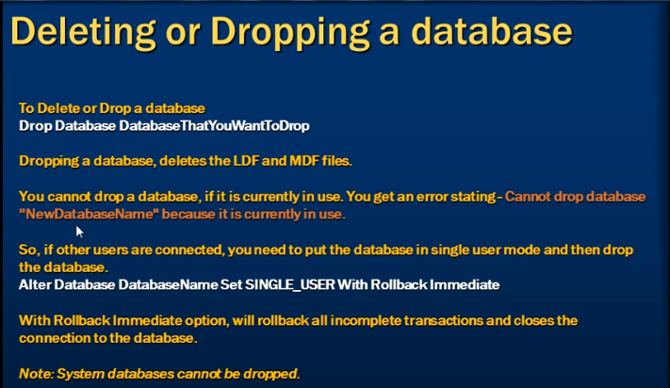

**How to create Tables:**

**Primary key is basically used to identify uniquely each record in the table.**

In SQL server, tables can be created graphically using SQL server Management Studio (SSMS) or using a query. Foreign key references can be added graphically using SSMS or using a query.

Graphically means Expand DB and Tables and Right click select table🡪new

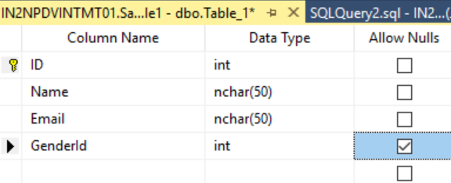

To select the Primary key right click on column i.e. in the above example ID and select primary key.

Save the DB with name and refresh the DB.

To create a table with SQL query:

Create Table tblGener

(

ID int NOT NULL Primary Key,

Gender nvarchar(50) NOT NULL

)

Note: Make sure the you select the correct DB from the Available Databases drop down

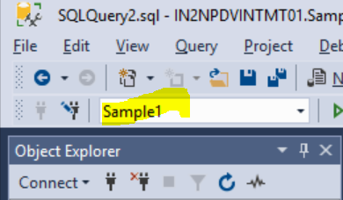

**Foreign Key:**

* Foreign keys are used to enforce data integrity.
* In layman’s term, a foreign key in one table points to a primary key in another table.
* The foreign key constraint prevents invalid data from being inserted into the foreign key column. The values you enter into the foreign key column, has to be one of the values contained in the table it points to.

In the below example, GenderID is the foreign key in the tblPerson which points to the primary key in the tblGender table.

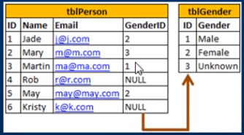

How to Mark foreign key:

1)Right click on the table🡪Design🡪Right click on the row which you want to mark as foreign key🡪select relationships🡪Add🡪Click Tables and Columns specific on the right hand side and click edit🡪select the columns

2)Alter table ForeignKeyTable add constraint ForeignKeyTable_ForeignKeyColumn_FK FOREIGN KEY (FOREIGN KEY COLUMN) references PrimaryKeyTable (PrimaryKeyColumn)

Alter table tblPerson add constraint tblPerson_GenderId_FK

FOREIGN KEY (GenderId) references tblGender (ID)

**Default Constraint:**

* A column default can be specified using DEFAULT Constraint.
* The default constraint is used to insert default value into a column.
* The default values will be added to all new records, if no other values specified, including null

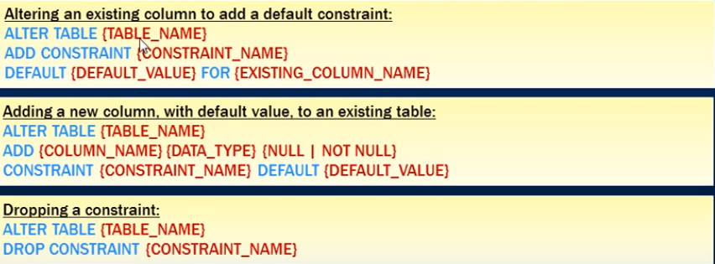

**Cascading Referrential Integrity:**

Cascading referential integrity constraint allows to define the actions Microsoft SQL servr should take when a user attempts to delete or update a key to which an existing foreign keys points.

For example: if you delete row with ID=1 from tblGender table, then row with ID=3 from tblPerson table becomes an orphan record. You will not be able to tell the Gender for this row. So, Cascading referential integrity constraint can be used to define actions Microsoft SQL Server Should take when this happens. By default, we get an error and the DELETE or UPDATE statement is rolled back.

Right click on the foreign key🡪Modify🡪Select Insert and Update Specification🡪you will see the below 4 options for the Delete/Update rule options.

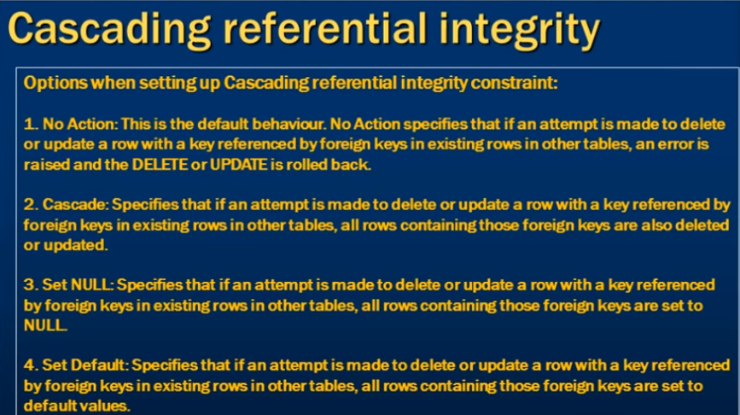

Check Constraint:

Check Constraint is used to limit the range of values, that can be entered for a column.

Syntax: ALTER TABLE TABLENAME

ADD CONSTRAINT (CONSTRAINT_NAME) CHECK (BOOLEAN EXPRESSION)

ALTER TABLE tblPerson

Add Constraint CK_tblPerson_Age CHECK (AGE > 0 AND AGE < 150)

If the BOOLEAN Value return TRUE, then the CHECK Constraint allow the value, otherwise it doesn’t. Since, AGE is a nullable column, it is possible to pass null for this column, when inserting a row. When you pass NULL For the AGE column, the BOOLEAN expression evaluates to UNKNOWN, and allows the value.

To drop the constraint :

ALTER TABLE TABLENAME DROP CONSTRAINT CONSTRAINTNAME

ALTER TABLE tblPerson

DROP Constraint CK_tblPerson_Age

**Identity Column:**

If a column is marked as Identity column, then the values for this column are automatically generated, when you insert a new row into the table

Create table tblPerson1

(

PersonId int Identity(1,1) Primary Key,

Name nvarchar(20)

)

Note: Seed and Increment values are optional. If you don’t specify the identity and seed they both default to 1.

CREATE TABLE tblPerson1

(

PersonId int Identity(1,1) Primary Key,

Name nvarchar(50)

)

Run the query Select * from tblPerson1

Result: No values in the table.

When you mark the column as Identity i.e. you don’t need to insert the values for that column.

Insert Into tblPerson1 Values ('Martin')

When you run the above query it will insert the values as below i.e. it will assign the value 1 for the PersonId column automatically

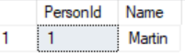

To explicitly supply a value for identity column

1. First turn on identity insert – SET Identity_Insert tblPerson1 ON
2. In the insert query specify the column list Insert into tblPerson1 (PersonId, Name) values (2,’John’)

If you have deleted all the rows in the table and you want to reset the identity column value, use DBCC CHECKIDENT Command

DBCC CHECKIDENT(‘tblPerson1’,RESEED,0)

**How to retrieve the last generated identity column value:**

By using the below 3 we can retreive

* SCOPE_IDENTITY()
* @@IDENTITY
* IDENT_CURRENT(‘TableName’)

We understand that identity column values are auto generated. There are several ways in SQL server, to retrieve the last identity value that is generated. The most common way is to use SCOPE_IDENTITY() built in function.

You can also use other two options.

Difference:

* SCOPE_IDENTITY(): Same session and Same scope
* @@IDENTITY: Same session and across any scope
* IDENT_CURRENT(‘TableName’): specific table across any section and any scope.

Select SCOPE_IDENTITY()

SELECT @@IDENTITY

SELECT IDENT_CURRENT(‘tblPerson’)

Unique Key Constraint:

We use Primary Key constraint to enforce uniqueness of a column i.e. the column should not allow any duplicate values. We can add a unique key constraint through the designer or using a query.

To create a unique Key constraint using a query:

Alter table tablename

Add constraint Constraint_Name Unique(ColumnName)

--Adding a constraint

Alter table tblPerson

Add Constraint UQ_tblPerson_Email Unique (Email)

--inserting a duplicate value into the table i.e.duplicate email id and you will get the below error

--Violation of UNIQUE KEY constraint 'UQ_tblPerson_Email'. Cannot insert duplicate key in object 'dbo.tblPerson'. The duplicate key value is (k@k.com ).

Insert into tblPerson values (8, 'Narayana' , 'k@k.com',2,null)

**Both Primary Key and Unique Key are used to enforce, the uniqueness of a column. So, when do you choose one over the other?**

A table can have only one primary key. If you want to enforce uniqueness on 2 or more columns, then we use unique key constraint.

**Difference between Primary Key Constraint and Unique Key Constraint?**

* A table can have, only one primary key, but more than one unique key.
* Primary Key doesn’t allow nulls, where as unique key allows one null.

--Dropping a constraint

Alter table tblPerson

Drop Constraint UQ_tblPerson_Email

**Select Query:**

**Like Operator:**

Retrieve the cities which are having name starts with L

select City from tblPerson where City like 'L%'

Find out all the email ids which have @ symbol in the Email column

select Email from tblPerson where Email like '%@%'

Find out all the email ids which has one character before @ and one character after @

select Email from tblPerson where Email like '_@_.com'

Find out all the names starts with M,S,T and it can be any characters after that

select Name from tblPerson where Name Like '[MST]%'

Find out all the names doesn’t starts with M,S,T and it can be any characters after that

select Name from tblPerson where Name Like '[^MST]%'

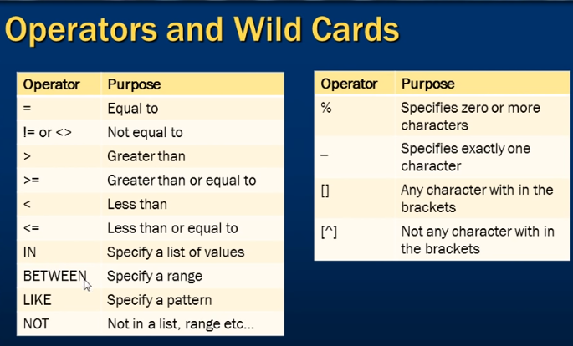

**--To retrieve top n rows from the table**

select top 3 * from tblPerson

**--To retrieve Percentage of rows from the table**

select top 20 Percent * from tblPerson

**--To retrieve the top Age from the table**

select top 1 * from tblPerson order by Age DESC

**Group By :** used to group a selected set of rows into a set of summary rows by the values of one or more columns or expressions. It is always used in conjunction with one or more aggregate functions.

Select city,gender, sum(salary) as Total Salary

from tblEmployee

group by city,gender

Select city,gender, sum(salary) as [Total Salary] , count(ID) as [Total Employees]

from tblEmployee

group by city,gender

**Where clause is used to filter rows before aggregation, where as HAVING clause is used to filter groups after aggregations.**

Select Gender, City , Sum(Salary) as [Total Salary], count(ID) as [Total Employees]

from tblEmployee

where Gender=’Male’

group by city,gender

Select Gender, City , Sum(Salary) as [Total Salary], count(ID) as [Total Employees]

from tblEmployee

group by city,gender

Having Gender=’Male’

**Difference between Where and Having Clause**

1)WHERE CLAUSE can be used with – Select , Insert and Update statements, whereas HAVING clause can only be used with the select statement.

2)WHERE Filters rows before aggregation(GROUPING), whereas , HAVING filter groups, after the aggregations are performed.

3)AGGREGATE functions cannot be used in the WHERE clause , unless it is in a sub query contained in a HAVING clause , where as , aggregate functions, can be used in Having clause.

**Joins in SQL :** used to retrieve data from 2 or more tables. In general tables are related to each other using foreign key constraints.

In SQL Server, there are different types of Joins

1. Inner Join
2. Outer Join
3. Cross Join

1)Inner Join: return only the matching rows between both the tables. Non Matching rows are eliminated.

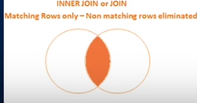

Select Name, Gender, Salary, DepartmentName

from employee JOIN department

ON employee.DepartmentId = department.ID

Select Name, Gender, Salary, DepartmentName

from employee INNER JOIN department

ON employee.DepartmentId = department.ID

**Left Outer Join / Left Join:** returns all the matching rows + non matching rows from the left table.

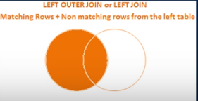

Select Name, Gender, Salary, DepartmentName

from employee Left Outer JOIN department

ON employee.DepartmentId = department.ID

Select Name, Gender, Salary, DepartmentName

from employee Left JOIN department

ON employee.DepartmentId = department.ID

**Right Outer Join / Right Join:** returns all the matching rows + non matching rows from the right table.

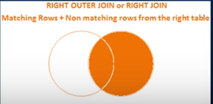

Select Name, Gender, Salary, DepartmentName

from employee Right Outer JOIN department

ON employee.DepartmentId = department.ID

Select Name, Gender, Salary, DepartmentName

from employee Right JOIN department

ON employee.DepartmentId = department.ID

**Right Outer Join / Right Join:** returns all the matching rows from both the right table and the left table, including the non matching rows.



Select Name, Gender, Salary, DepartmentName

from employee Full Outer JOIN department

ON employee.DepartmentId = department.ID

Select Name, Gender, Salary, DepartmentName

from employee Full JOIN department

ON employee.DepartmentId = department.ID

CROSS Join: Produces the cartesian product of the2 tables involved in the join. For Example, in the employees table we have 10 rows and in the department table we have 4 rows . so a cross between these 2 tables will be 40 rows.

Note: CROSS Join should not have ON Clause.

Select Name, Gender, Salary, DepartmentName

from employee CROSS JOIN department

Summary on Joins:

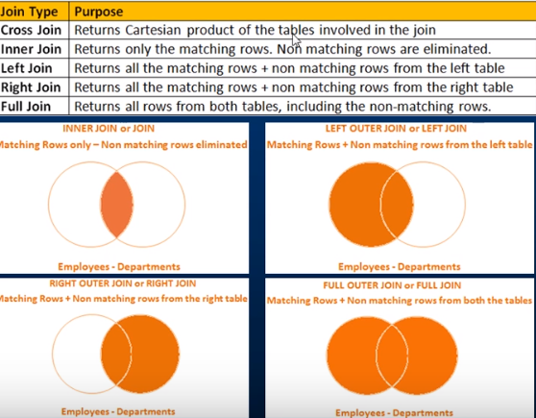

**To retrieve only the non matching rows from the left table**

SELECT Name, Gender, Salary, DepartmentName

From Employee

Left join department

On employee.departmentid=department.id

Where employee.departmentid IS NULL

SELECT Name, Gender, Salary, DepartmentName

From Employee

Left join department

On employee.departmentid=department.id

Where department.id IS NULL

**To retrieve only the non matching rows from the RIGHT table**

SELECT Name, Gender, Salary, DepartmentName

From Employee

Right join department

On employee.departmentid=department.id

Where employee.departmentid IS NULL

**To retrieve only the non matching rows from both the RIGHT table and LEFT Table**

SELECT Name, Gender, Salary, DepartmentName

From Employee

FULL join department

On employee.departmentid=department.id

Where employee.departmentid IS NULL

OR department.id IS NULL

SELF Join: Joining a table with itself

It can be classified as

1)Inner Self Join

2)Outer Self Join (Left, Right and Full)

3)Cross Self Join

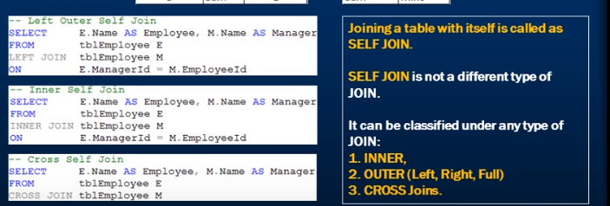

**Replace Null values:**

Instead of printing the NULL in the column value we can replace the value of NULL with different word. For Example, if the employee doesn’t have manager, then instead of printing NULL we can replace the word NULL with ‘No Manager’

Three way to replace null values:

**1)ISNULL() function :** if the column returns null value it replace the null value with the replacement value.

Syntax: ISNULL(Expression, ‘REPLACEMENT VALUE’)

In the below example M.Name is returning null value so we are replacing that value with ‘No Manager’ value.

Select E.Name as Employee, ISNULL(M.Name,’No Manager’) as Manager

From employee E

Left Join employee M

On E.ManagerID=M.ManagerID

**2)COALESCE Function:** it is basically used to retrun the first non null value.

Select E.Name as Employee, COALESCE(M.Name,’No Manager’) as Manager

From employee E

Left Join employee M

On E.ManagerID=M.ManagerID

**3)CASE Statement:**

Syntax: CASE when Expression THEN ‘ ‘ ELSE ‘ ‘ END

Example:

Select E.Name as Employee, CASE When M.Name is Null THEN ‘No Manager’ ELSE M.Name END as Manager

From employee E

Left Join employee M

On E.ManagerID=M.ManagerID

COALESCE Function: returns the first NON NULL value

Look at the below Employee table. It has first Name, Middle Name and Last Name. Some of them has firstName and some of them has Middle Name and Some of them has LastName. Now we want to write the query which pulls out Id and Name of the person. Now when you pull out the name

1. if the employee has first name you pull that name
2. if the employee does not have a first name and has middle name and last name then pull his middle name
3. if the employee does not have a first name , middle name and has only last name then pull his last name

This can be achieved by using COALESCE function

Select id, COALESCE(FirstName, MiddleName, LastName) as Name from Employee

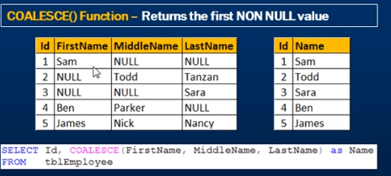

UNION and UNION ALL

UNION and UNION ALL operators in SQL Server , are used to combine the result set of two or more SELECT queries.

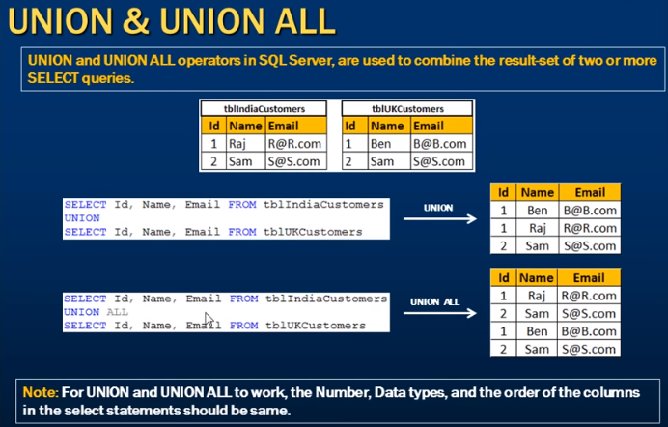

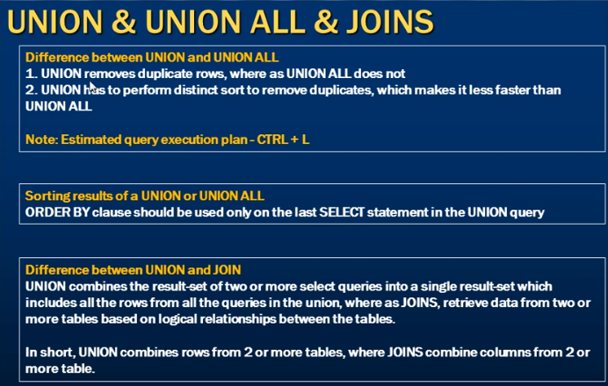

**Stored Procedures:**

A Stored Procedure is a group of T-SQL(Transacted) Statements. If you have a situation, where you write the same query and over again, you can save that specific query as a stored procedure and call it just by its name.

**1.Use CREATE PROCEDURE or CREATE PROC statement to create SP**

Note: when naming user defined stored procedures, Microsoft recommends not to use sp_ as prefix. All system stored procedures, are prefixed with sp_. This avoids ambiguity between user defined and system stored procedures and any conflicts, with some future system procedure.

**To Execute the Stored Procedure**

1.storedprocedurename (EG: spGetEmployees)

2.EXEC spGetEmployees

3.Execute spGetEmployees

Note: you can also right click on the procedure name, in object explorer in SQL server Management Studio and select EXECUTE Stored procedure.

Creation of Stored Procedure:

CREATE PROCEDURE PROCEDURENAME

AS

BEGIN

SQL STATEMENT

END

Create procedure spGetEmployees

As

Begin

Select Name, EmployeeID from Employee

End

**Stored Procedure with Parameters:**

Create Procedure spGetEmployeeByGenderAndDepartment

@Gender nvarchar(20),

@DepartmentId int

As

Begin

Select Name, Gender, DepartmentId from tblEmployee

Where Gender = @Gender and DepartmentId = @DepartmentId

End

To execute the above stored Procedure:

spGetEmployeeByGenderAndDepartment ‘Male’ , 1

Execute spGetEmployeeByGenderAndDepartment ‘Male’ , 1

Execute spGetEmployeeByGenderAndDepartment @DepartmentId= 1, @Gender=’Male’

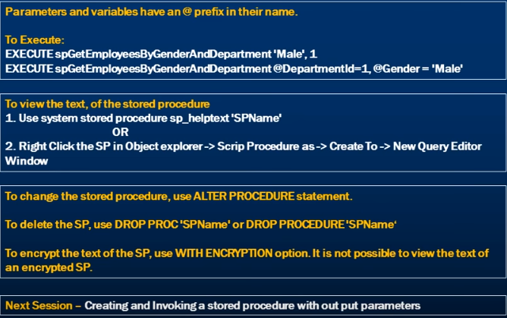

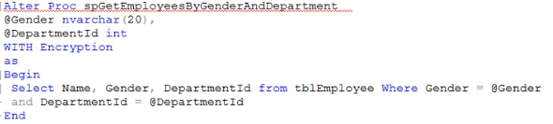

**Creating Stored Procedures without Output Parameters:**

To create an SP without Output Parameter , we use keywords OUT or OUTPUT.

**--Creating a SP with output Parameters**

Create Procedure spGetEmployeeCountByGender

@Gender nvarchar(20),

@EmployeeCount int Output

As

Begin

Select @EmployeeCount = COUNT(ID) from employee where Gender = @Gender

End

**--To execute the stored procedure with Output Parameters**

Declare @EmployeeTotal int

Execute spGetEmployeeCountByGender 'Male', @EmployeeTotal Output

Print @EmployeeTotal

Note: if you don’t specify the ‘OUTPUT’ keyword when executing the stored procedure , the @EmployeeTotal will be null.

If you are passing the values with parameters then the order of passing the variables is not necessary.

Declare @EmployeeTotal int

Execute spGetEmployeeCountByGender @EmployeeCount= @EmployeeTotal Output, @Gender = 'Male'

Print @EmployeeTotal

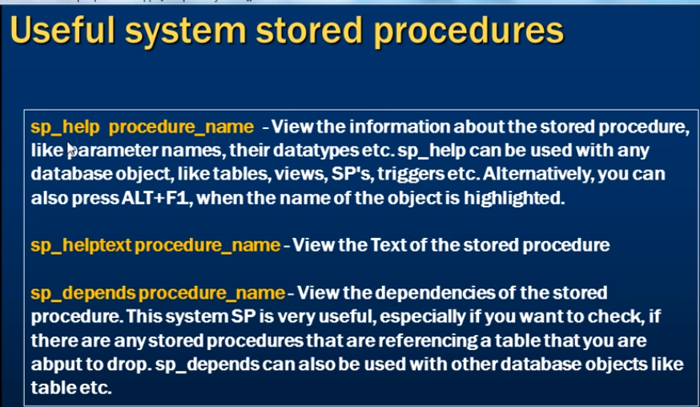

Examples:

Sp_help spGetEmployeeCountByGender

Sp_employee

Sp_helptext spGetEmployeeCountByGender

Sp_depends spGetEmployeeCountByGender

**Stored Procedure return Values:**

**Whenver, you execute a stored procedure, it returns an integer status variable, usually , Zero indicates success, and non-zero indicates failure.**

**---Creating a Stored Procedue with output parameters**

Create Proc sp_getTotalCount1

@TotalCount int output

As

Begin

Select @TotalCount = COUNT(ID) From employee

End

Declare @Total int

Execute sp_getTotalCount1 @Total Out

Print @Total

**-----Creating a Stored Procedue with return values**

Create Proc sp_getTotalCount2

As

Begin

return (Select COUNT(ID) From employee)

End

Declare @TotalEmployeeCount int

Execute @TotalEmployeeCount=sp_getTotalCount2

Print @TotalEmployeeCount

**So, we are able to achieve what we want, using Output Parameters as well as return values.**

**Now, let’s look at example, where return status variables cannot be used, but output Parameters can be used.**

--Creating an SP with Output Parameters

Create Proc spGetEmployeeNameByID1

@ID int,

@Name nvarchar(20) output

As

Begin

Select @Name = Name from employee where @ID = ID

End

Declare @Name nvarchar(20)

Execute spGetEmployeeNameByID1 1 , @Name Out

Print ' Name = ' + @Name

Output:

Name = Todd

--creating the same SP with return values

Create Proc spGetEmployeeNameByID2

@ID int

As

Begin

return (Select Name from employee where @ID = ID)

End

Declare @Name nvarchar(20)

Execute @Name=spGetEmployeeNameByID2 1

Print ' Name = ' + @Name

**Output is:**

Conversion failed when converting the nvarchar value 'Tom' to data type int.

**Because the output of the return values should always be integer but here we are trying to return the value as String and it got failed with the message .**

**Difference between Return value and output values**

1)When we use return statement it always returns an integer value

2)The return statement always return only one return value i.e.

**We cannot use this statement as it is returning two int values i.e. Id and Department id** return (Select Id, DeparmentID from employee where @ID = ID)

**We can use this** return (Select Id from employee where @ID = ID)

**We cannot use this statement as it is returning string value and int values i.e. Name and Department id** return (Select Name, DeparmentID from employee where @ID = ID)

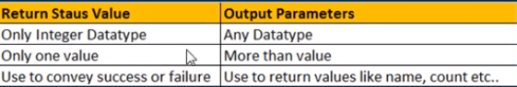

**Advantages of Stored Procedures Over adhoc queries :**



**Buit in String Functions:**

User defined functions

System defined functions(Built in Functions)

When you expand Databases🡪Database(Sample1) 🡪 Programmability 🡪 System functions you will see all the in built functions

String functions:

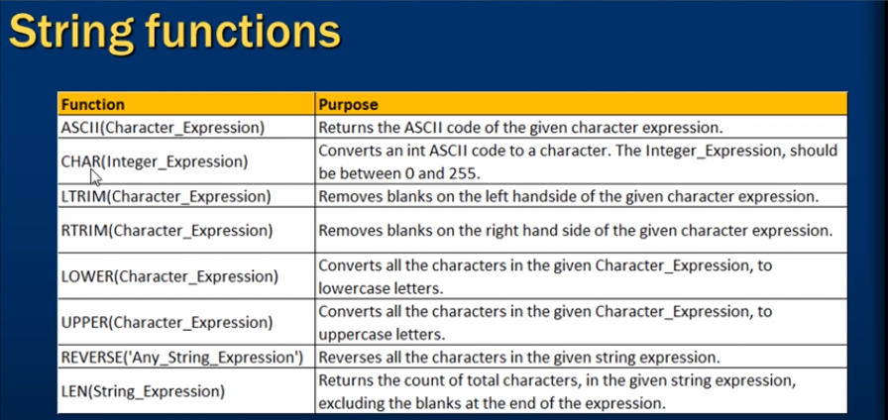

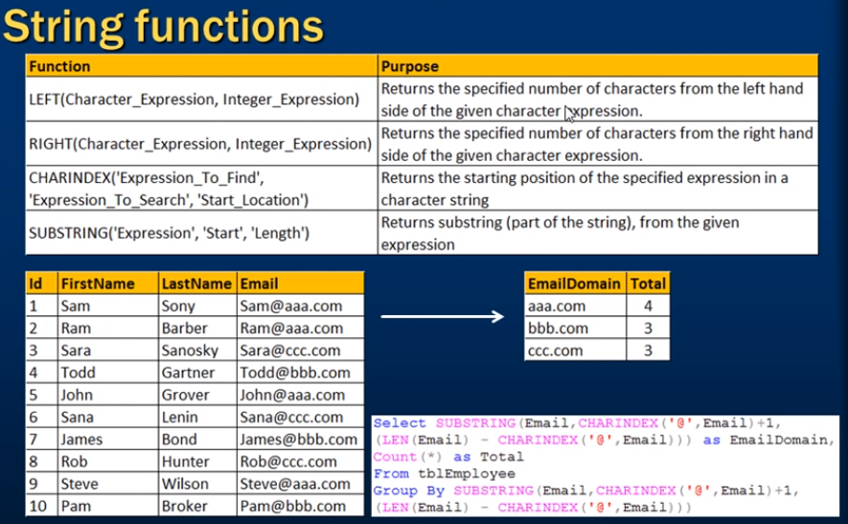

select ASCII('A') --output 65

Select ASCII('a') --output 97

Select CHAR(65) -- output A

--To print alphabets from A to Z using Ascii value

Declare @Start int

Set @Start = 65

While(@Start <=90)

Begin

Print Char(@Start)

Set @Start = @Start + 1

End

--To print alphabets from a to z using Ascii value

Declare @Start int

Set @Start = 97

While(@Start <=122)

Begin

Print Char(@Start)

Set @Start = @Start + 1

End

select reverse(Name) from Employee

select Name,LEN(Name) as [Total Characters] from employee

select LEFT('Narayana',4) --output Nara

select RIGHT('Narayana',2) --output na

--returns the string position of the specified expression in a character string

--Syntax: CHARINDEX('expression to find' , 'Expresson to search',Starting position)

select CHARINDEX('@','narayana.10209@gmail.com',1) --output 15

--Substring function : returns substring from the starting position

--Syntax: SUBSTRING('EXPRESSION','Start position','length(how many characters you want to print')

select SUBSTRING('narayana.10209@gmail.com',16,9) -- output gmail.com

select email from tblPerson

select CHARINDEX('@',Email)+1 from tblPerson -- returns the index of @ in each row for Email column. If you dont use +1 then it will give the index including @.

select LEN(Email) from tblPerson --return the length of the email column for each row

select CHARINDEX('@',Email) from tblPerson -- returns the returns the index of @ in each row for Email column including @

select LEN(Email) - CHARINDEX('@',Email) from tblPerson --

--sam@sam.com 11-4

--To Print the domain names from the Email column

select SUBSTRING(Email,CHARINDEX('@',Email)+1, LEN(Email) - CHARINDEX('@',Email))

as DomainName

from tblPerson

--To print the domain names and count of the email column

select SUBSTRING(Email,CHARINDEX('@',Email)+1, LEN(Email) - CHARINDEX('@',Email)) as DomainName,COUNT(Email)

as DomainNameCount from tblPerson

Group by SUBSTRING(Email,CHARINDEX('@',Email)+1, LEN(Email) - CHARINDEX('@',Email))

Replicate Function: Repeats the given string, for the specified number of times.

Syntax: Replicate(‘String to be replicated’,Number of times to replicate)

select Name,

SUBSTRING(Email,1,2) + REPLICATE('*',5) +

SUBSTRING(Email, CHARINDEX('@',Email) , LEN(Email) - CHARINDEX('@',Email) +1 )

As Email

from tblPerson

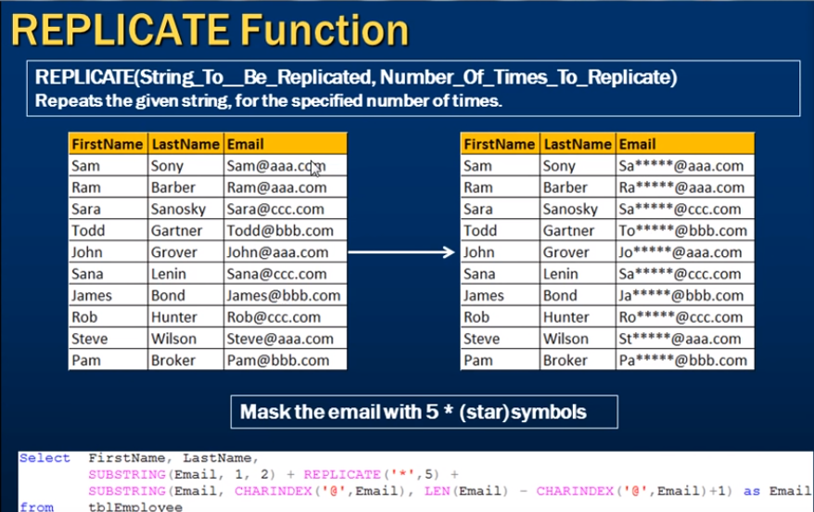

**Space function:**

Returns number of spaces , specified by the number of spaces argument.

Example: The space(5) function inserts 5 spaces

Select FirstName + Space (5) + LastName as FullName from employee

PATINDEX Function:

Returns the starting position of the first occurrence of a pattern in a specifeid expression. It takes two arguments , the pattern to be searched and the expression.

PATINDEX() is similar to CHARINDEX(). With CHARINDEX() we cannot use wildcards, where as PATINDEX() provides this capability. If the specified pattern is not found, PATINDEX returns zero.

Syntax: PATINDEX(‘%Pattern%’, Expression)

select Email, PATINDEX('%@aaa.com',Email) as FirstOccurence from tblPerson

where PATINDEX('%@aaa.com',Email) > 0

Output:

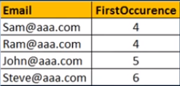

**Replace function:**

Replaces all occurences of a specified stirng value with another string value.

REPLACE(STRING EXPRESSION, PATTERN, REPLACEMENT_VALUE)

SELECT EMAIL, REPLACE(EMAIL, ‘.com’, ‘.net’) as convertedEmail from employee

All .com strings are replaced with .net string.

**STUFF Function:**

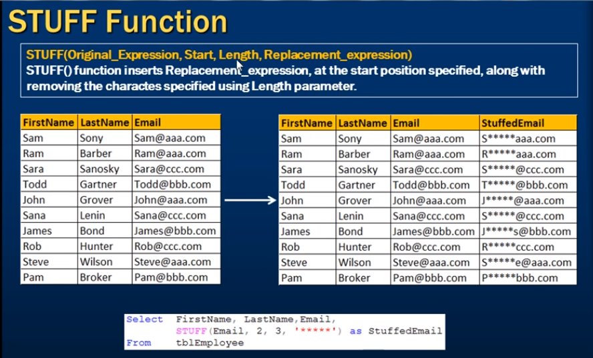

**DateTime Functions**

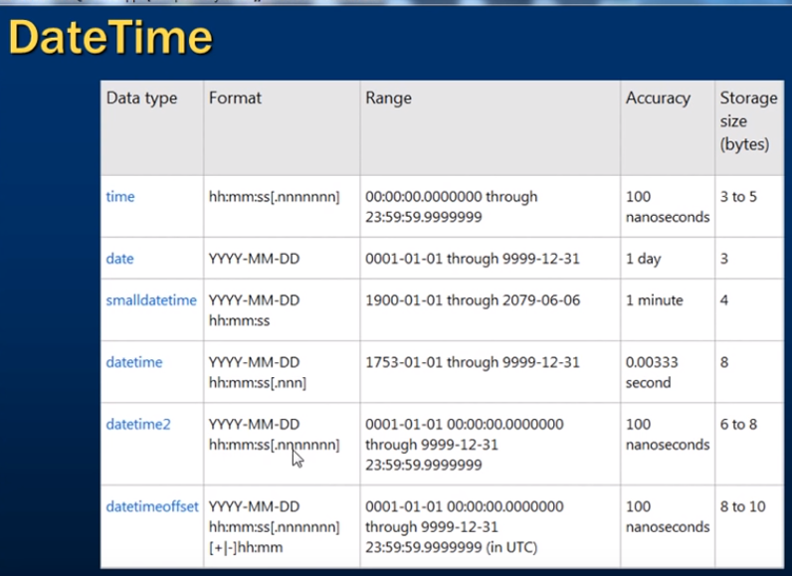

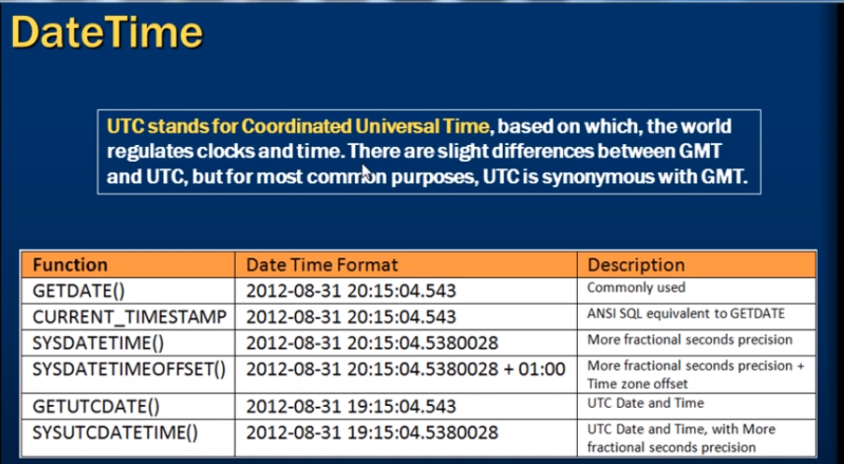

--isDate() - checks if the given value is a valid date, time , or datetime. Returns 1 for success and 0 for failure

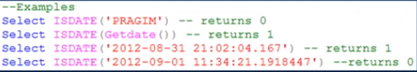

For datetime2 values, IsDate returns 0.

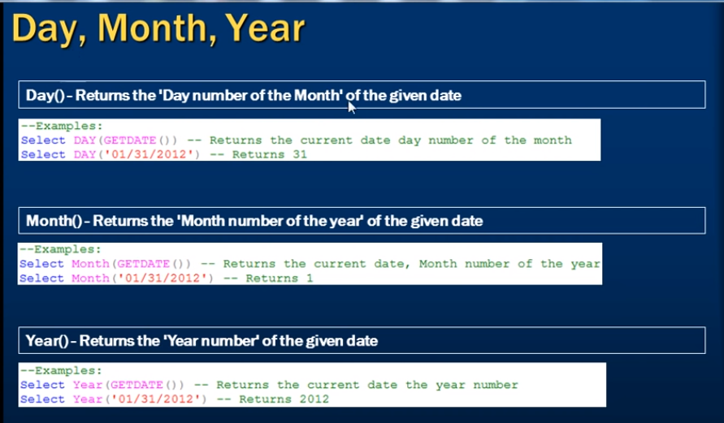

select DAY(GETDATE())

select MONTH(getdate())

select YEAR(GETDATE())

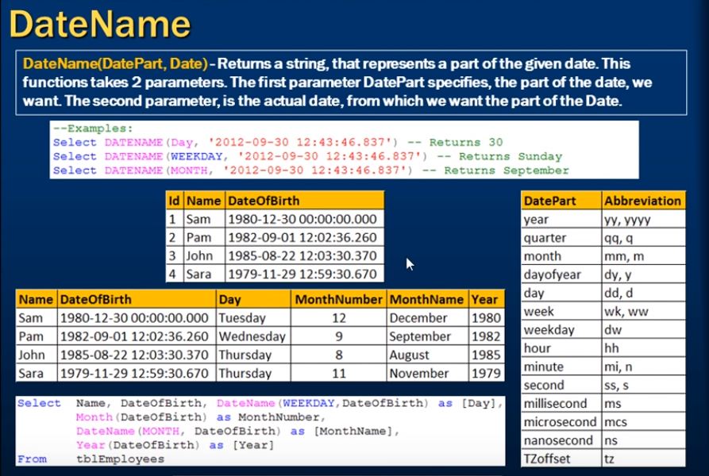

select DATENAME(weekday,GETDATE()) -- output thursday

select DATENAME(year, GETDATE()) --output 2019

select DATENAME(month,GETDATE()) --output March

select DATENAME(week, GETDATE())

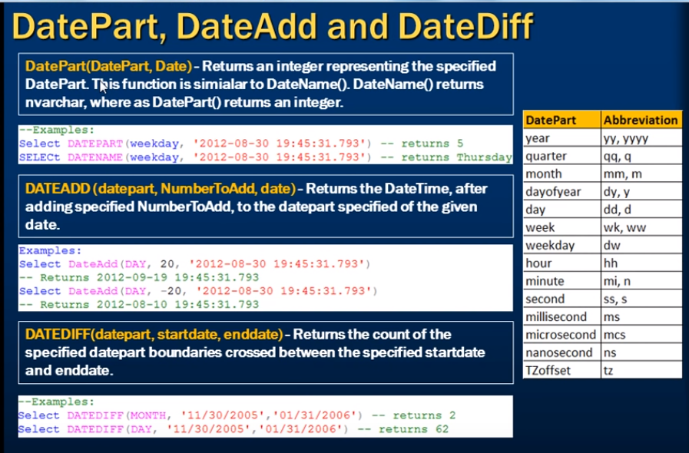

Consider the employees table below

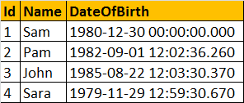

create table dateEmployees(

id int primary key,

Name nvarchar(50) ,

DateOfBirth smalldatetime

)

select * from dateEmployees

insert into dateEmployees values(1,'Sam','1980-12-30 00:00:00:000')

insert into dateEmployees values(2,'Pam','1982-09-01 00:02:36:260')

insert into dateEmployees values(3,'John','1985-08-22 00:03:00:000')

insert into dateEmployees values(4,'Sara','1987-11-29 00:00:00:000')

insert into dateEmployees values(5,'Nara','1991-12-04 00:00:00:000')

Write a query to compute the age of a person, when the date of birth is given. The output should be as shown below.

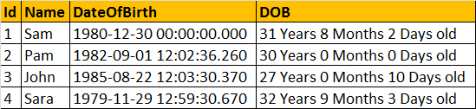

CREATE FUNCTION fnComputeAge(@DOB DATETIME)

RETURNS NVARCHAR(50)

AS

BEGIN

DECLARE @tempdate DATETIME, @years INT, @months INT, @days INT

SELECT @tempdate = @DOB

SELECT @years = DATEDIFF(YEAR, @tempdate, GETDATE()) -

CASE

WHEN (MONTH(@DOB) > MONTH(GETDATE())) OR (MONTH(@DOB) = MONTH(GETDATE()) AND DAY(@DOB) > DAY(GETDATE()))

THEN 1 ELSE 0 END

SELECT @tempdate = DATEADD(YEAR, @years, @tempdate)

SELECT @months = DATEDIFF(MONTH, @tempdate, GETDATE()) -

CASE WHEN DAY(@DOB) > DAY(GETDATE())

THEN 1 ELSE 0 END

SELECT @tempdate = DATEADD(MONTH, @months, @tempdate)

SELECT @days = DATEDIFF(DAY, @tempdate, GETDATE())

DECLARE @Age NVARCHAR(50)

SET @Age = Cast(@years AS NVARCHAR(4)) + ' Years ' + Cast(@months AS NVARCHAR(2))+ ' Months ' + Cast(@days AS NVARCHAR(2))+ ' Days Old'

RETURN @Age

End

To execute the above funciton

Select Id, Name, DateOfBirth, dbo.fnComputeAge(DateOfBirth) as Age from dateEmployees

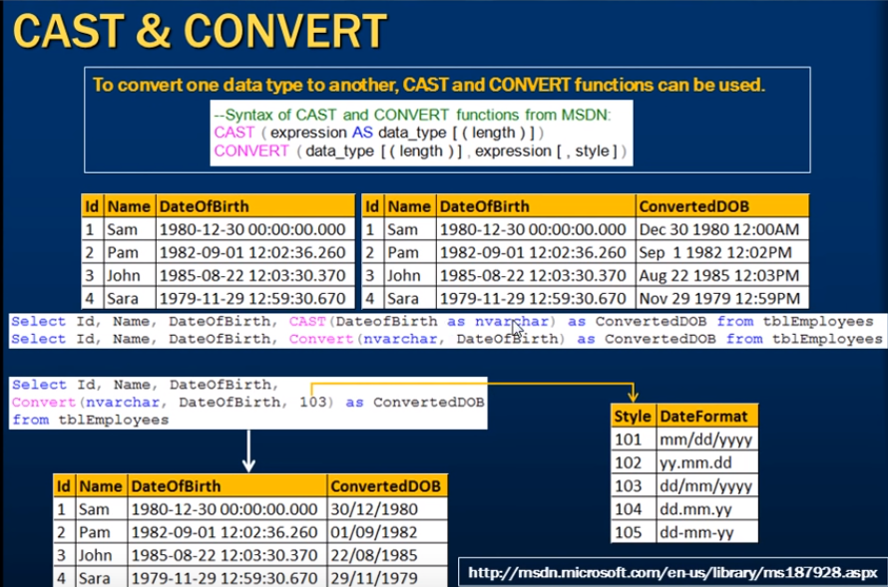

--cast(column name As datatype) exmaple

select id,name,dateofbirth , cast(DateofBirth as nvarchar ) as convertedDOB from dateEmployees

--convert(datatype to convert, column name, [style]) style is optional

select id,name, dateofbirth , CONVERT(nvarchar, DateofBirth,103) as convertedDOB from dateEmployees

